**Vector Components and Vector Addition**

Estimated completion time: less than 60 minutes, including watching the background material videos.

Record your answers in this document and upload it to Canvas before the due date for credit. When you paste in a screenshot of anything here, make sure it is large enough to read easily.

**NOTE**: Think of the activities at Pivot Interactives or any other simulation source as if they are equipment on your lab table. You are encouraged to play with all the settings, change the trials, make your own measurements, do calculations, and explore as much as you like. The only exception will be “locking in” your answers at Pivot Interactives, which we will cover later.

**Record units on all reported numbers.**

Your Name: Answer here

At the end of this lab, you will be asked to record the time it takes to complete this lab.

Record starting time here

Lab Partner Names:

1. _____________________
2. _____________________
3. _____________________
4. _____________________

**These lab instructions** have **Parts** and **Tasks** that are in bold, while references to PI have Parts and Item numbers that are all underlined.

**Background Material (take notes!):**

Vectors can be position, velocity, acceleration, forces, and more. Here we investigate position vectors, vector addition, and force vectors. We consider not only the result of vector addition, but for forces, the opposite of a resultant vector, called an equilibrant - or the vector that would bring a system into equilibrium if the other forces are known.

Displacement Vectors and Adding Multiple Vectors (analyzed graphically)

<https://youtu.be/p1JeuN593qI>

Trig Review for 2D Vectors

<https://youtu.be/2E_O_CR9FA8>

Using the PhET Simulation:

<https://youtu.be/EWMEVxhbRIM>

The Force Table:

<https://youtu.be/-afmQUEG9BQ>

**Part 1: Warm-Up Exercises “Vector Treasure Hunt”**

**Task 1: One Step Vector Treasure Hunt (10 points)**

Goal: Demonstrate ability to determine the end point for a single vector

Link to simulation: <https://www.thephysicsaviary.com/Physics/Programs/Games/VectorTreasureHuntSimple/>

Click “Begin” and you will be presented with a vector of some length and some angle in degrees measured counterclockwise from the positive x-axis.

**1.1.1:** Read the directions in the simulation and click on the proper place in the grid to indicate the ending point of the vector. After you achieve proficiency, the simulation will present you with a window where you input your name. Enter your name, and you will get a certificate of completion. It will look like this – note that your name will be shown. For credit on this activity, remove this certificate and paste in your own. Make sure it is large enough for your name to be easily read.

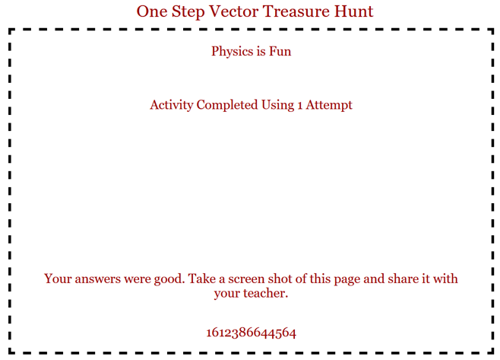

**Task 1.2: Vector Treasure Hunt (20 points)**

Goal: Demonstrate ability to determine the end point after adding three vectors

Link to simulation: <https://www.thephysicsaviary.com/Physics/Programs/Games/VectorTreasureHunt/>

Click “Begin” and you will be presented with **three** vectors of some length and some angle in degrees measured counterclockwise from the positive x-axis.

**1.2.1:** Read the directions in the simulation and click on the proper place in the grid to indicate the ending point of the sum of the three vectors. (Hint: find the x and y components of each of the three vectors, then add them together to find the resultant vector) After you achieve proficiency, the simulation will present you with a window where you input your name. Enter your name, and you will get a certificate of completion. It will look like this – note that your name will be shown. For credit on this activity, remove this certificate and paste in your own. Make sure it is large enough for your name to be easily read.

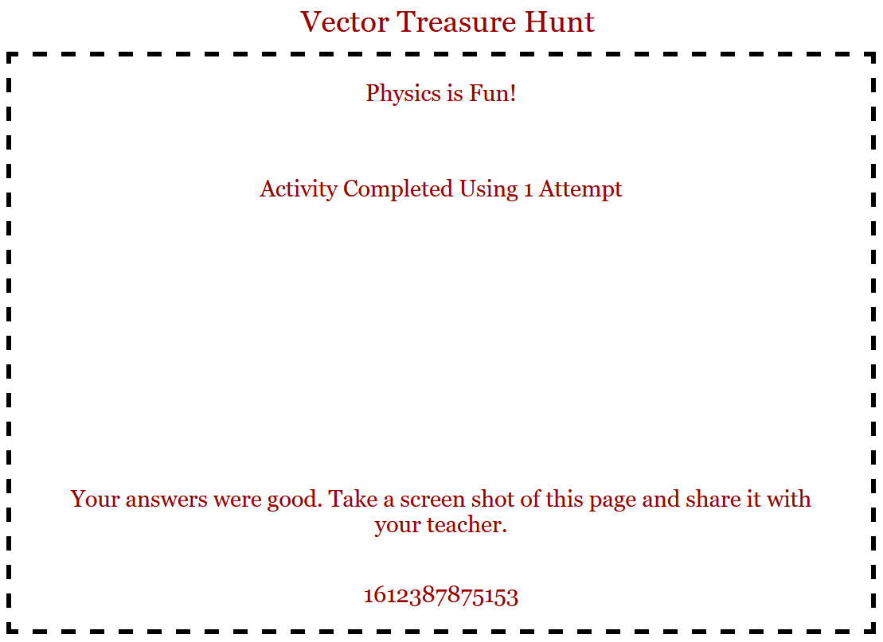

**Part 2: Simulated Force Table**

Normally we would do this lab with a force table as shown in the video at the start of this lab.

The resultant force ($F_{r}$) of two forces $F_{1}and F_{2}$ can be found by one of two methods: by the analytical method or by graphical method.

The analytical method is using algebra and trigonometry to mathematically determine the resultant.

Each force vector such as thoseshown below**,** which makes an angle $θ$ with horizontal +x- axis, can be resolved into two components. Those components are horizontal or x-component ( $F_{x})$ and vertical or y- components ($F_{y})$. In this case, the components are given by:



Consider the case of three force vectors: **F1, F2, F3**. The resultant, $F_{R}$**,** is still found in the following manner:

$$F_{Rx}=F_{1x}+F_{2x}+F_{3x} ; F_{Ry}=F_{1y}+F_{2y}+F_{3y}$$

Where each component of the corresponding force vectors is found using $Sinθ, Cosθ, or Tanθ$ in a manner similar shown previously.

The magnitude of the resultant vector (FR) is found using the following formula, because the components $F_{Rx}$ and $F_{Ry}$ are at right angles:

$$|F_{R}|=\sqrt{{\left(F_{Rx}\right)}^{2}+{\left(F_{Ry}\right)}^{2}}$$

and the angle, $θ$, that the resultant force vector makes with the $+x axis$ is given by reasoning from

$$Tan(θ)=\frac{F_{Ry}}{F_{Rx}}$$

In the graphical addition method, the resultant vector is the vector drawn from the tail of the first vector to the head of the last vector; the polygon method is illustrated for the case of three vectors as follows:





To verify the objectives experimentally we will use PHET simulation software for two scenarios, the first where we have two forces and the second with three forces. Your goal will be to calculate the resultant by finding the equilibrant force, $F_{E}$.

**FE**is the equilibrant force that must be applied in order to keep an object in equilibrium or balanced. The magnitude and direction of this **FE** can be found by trial and error experimentally. The resultant force **FR** can be found from the premise that **FR** and **FE** have the same magnitude but opposite direction.

This is because three vectors being superimposed act as if there is a single vector doing that same operation, which is what we call the resultant. So naturally, to balance this you need a vector of equal magnitude but pointing in the opposite direction. Think of a tug-of-war between two sides, the rope is in equilibrium due to two equal, but opposite forces.

**Task 2.1: Two forces acting on a ring using the Force Table (Experimental Method) (10 points)**

Link to simulation: <https://phet.colorado.edu/sims/html/vector-addition/latest/vector-addition_en.html>

Set up the simulation with the following steps.

Select “Explore 2D”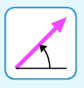

Click the icon next to the reset button that sets the sim for a length and an angle (polar coordinates):

Use $F_{1}$ as vector **“d”** and $F_{2}$ as vector **“e”** on the PHET simulation. The “ring” for this simulation will be the gray dot at the origin of our coordinate system (you can drag and drop the vectors there). We are attempting to achieve equilibrium or a balance of force vectors on this dot.

Place the first vector (**F1**) at a 20o angle and make its magnitude 10N. *(vector* ***d****)*

Place the second vector (**F2**) at a 90o angle and make its magnitude 8N. *(vector* ***e****)*

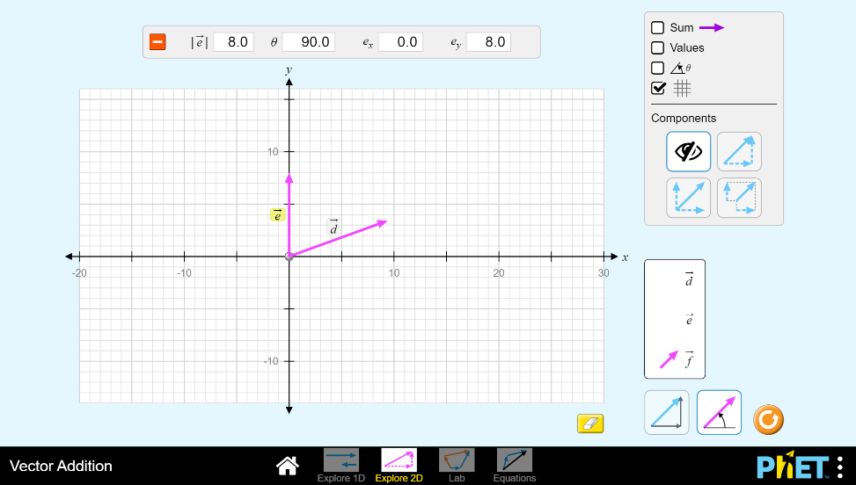

Use vector ***f*** as a third force vector, (which will be **FE**) acting on the ring, click on the sum option on the simulation screen to show you the sum of the three forces **F1**, **F2**and **FE**. The sum vector will show up as “ $s"$.

Use simple trial and error to control the vector ***f*** *(***FE**) in magnitude and direction where the resultant force vector must be close to zero (“**s**” must have a magnitude of less than approximately 0.5.) Stop changing vector ***f*** (**FE**) and then fill-in your findings below.

**2.1.1:** (exp) = ________________

**2.1.2:** (exp) = ________________

Find the resultant force, (exp) (magnitude and direction)

**2.1.3:** (exp) = _____________

**2.1.4:** (exp) = _______________

**Task 2.2: Two forces acting on a ring using the Force Table (Analytical Method) (10 points)**

Using the PHET simulation, click on the x-y components button in the lower right corner, and then click on each vector shown on the graph to display the vectors’ components **F1x, F2x, F1y, F2y,** then record your values in table 2.1 below. The component values will be visible at the top of the PhET page as shown here: **BE CAREFUL: VALUES SHOWN ARE JUST EXAMPLE. You need same values as 2.1(ANALYTICAL)**

Use the analytical method to find **FR** (of the two forces **F1** and **F2**) magnitude and direction. Record these as well in Table 2.1 below. This is essentially identical to the analytical methods performed in lecture problems or homework problems.

Show work here

**Table 2.1 — Analytical Solution**

|  |  |  |  |  |
| --- | --- | --- | --- | --- |
| **Force** | **Force Magnitude (N)** | **Direction** | **x-component** | **y-component** |
| **F1** | Answer | **20o** | Answer | Answer |
| **F2** | Answer | **90o** | Answer | Answer |
| **FR** | Answer | Answer | Answer | Answer |

Calculate the percentage error of the magnitude of the experimental value of **FRexp.** compared to analytical solution (analytical can be theoretical in this case) for **FR**.

**Task 3: Three forces acting on a ring on a force table. (10 points)**

Place the first vector ($F_{1}$) at approximately 300 make its magnitude 6N.

Place the second vector ($F_{2}$) at approximately 100o angle make its magnitude 8N.

Place a third vector ($F_{3}$), at approximately 145o and make its magnitude 11N.

This time, find the resultant force, $F_{R}$, of these three forces using the PHET simulation. Record your values below.

**3.3.1:** (exp) = _____________

**3.3.2:** (exp) = _______________

Write down the value of **FE** and it is direction. (Remember the relationship to $F_{R}$.)

**3.3.3:** (exp) = _____________

**3.3.4:** (exp) = _______________

Click on the x-y components button shown above and then click on each vector shown on the graph paper to display the vectors’ components **F1x, F2x, F1y, F2y, F3x**, **F3y.** Use the analytical method to find **FR** (of the three forces **F1**, **F2** and **F3**) magnitude and direction. Record your values in table 3.2.

**Table 3.2 — Resultant from Three vectors (Analytical Solution)**

|  |  |  |  |  |
| --- | --- | --- | --- | --- |
| **Force** | **Force ( N )** | **Direction** | **x-component** | **y-component** |
| **F1** | Answer | **30o** | Answer | Answer |
| **F2** | Answer | **100o** | Answer | Answer |
| **F3** | Answer | **145o** | Answer | Answer |
| **FR** | Answer | Answer | Answer | Answer |

**3.3.5** Calculate the percentage error of the magnitude of the experimental value of **FRexp.** compared to analytical solution for **FR**.

**3.3.6:** Attach a screenshot of your resulting simulation at the end for this part as well.

Screen shot here

**3.3.7:** Write a paragraph (Conclusions) for this lab with your statements about what you learned in this lab. Include the equilibrant vector (magnitude and direction) for the three- vector activity.

Answer here

Tell **how much time** it took you to complete this lab. Please tell **what device** you used to complete this lab. Please tell if your **device** caused you any **troubles**. Please tell if any of the **instructions** or **parts of the simulation** were not clear. We will use this feedback to improve the activity. Thank you!

Record the total amount of time spent completing this lab activity here

Additional answer here